Poverty, Children, and the Use of Information and Communications Technology

A policy brief by

Folagbade Akinwunmi Mosaku (University of Ibadan, Nigeria), Lu Liu (Sydney Conservatorium of Music, University of Sydney), Manimala Chanu Asem (University of Bergen, Norway), Rahel Hauk (University of Wageningen, the Netherlands), Stefanie Mallow (University of Costa Rica), Vijaya (Indian Institute of Technology Guwahati, India) and Zinzi Magoda (Cape Peninsula University of Technology, SA)

Introduction

The global Covid-19 Pandemic has changed the world. In 2022, we are slowly starting to see the short and long-term effects lockdowns, school-closures, and limited social contacts had on children around the globe. One of those effects is the changed behaviour in terms of information and communications technology (ICT). Various studies point towards an increase of ICT use among children during and after the Pandemic, changing learning and behaviour. Yet, many children who had access to ICTs were left behind in their learning processes, leading to lifelong disadvantages (Word Economic Forum, 2021)

In 2015, the Transforming our World: the Global Agenda on Sustainable Development, commonly known as Agenda 2030, pointed out that “The spread of information and communications technology and global interconnectedness has great potential to accelerate human progress, to bridge the digital divide and to develop knowledge societies, as does scientific and technological innovation across areas as diverse as medicine and energy.” (Article 15).

In the same vain, information and communication technology is referenced in various targets of the Sustainable Development Goals (SDGs), most prominently in SDG 9.c, which calls for increased access to ICTs in least developed countries.

World Bank data show that access to the internet is exponentially increasing worldwide, with over 60% of the world population in 2020 having access to the internet. Yet, a UNICEF report from 2020 highlighted that “2 in 3 children and young people aged 25 years or less do not have internet access at home”, with large discrepancies between low and high income countries. The future is digital, which means that children without proper technology education will miss out on work and other opportunities leading to increased inequality and poverty.

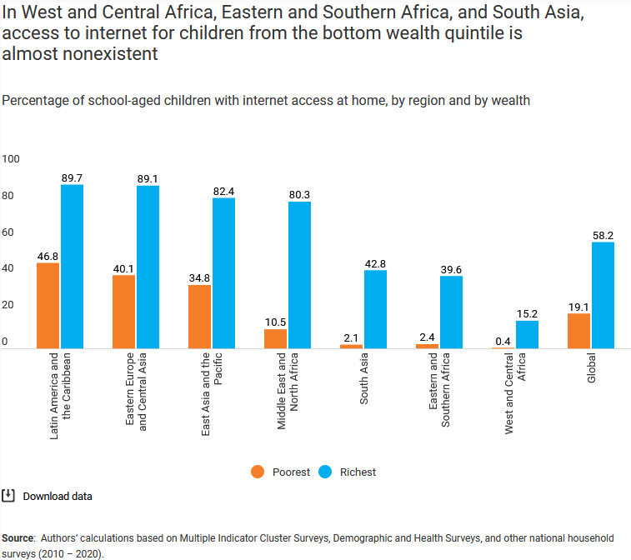

Figure 1: Internet access for poorest and richest children by region
(Source: https://blogs.unicef.org/evidence-for-action/where-do-children-have-internet-access-at-home-insights-from-household-survey-data/ (last accessed June 15th, 2022)

Yet, ICTs are not just a panacea to equality, they also pose real dangers to mental and physical health due to unsupervised over- and misuse. Especially mental health issues among children are raising, not least due to social media and internet access.

Problem Statement

The use of information and communications technology (ICT) is increasing all over the world. Children with access to digital gadgets spend an increasing amount of time per day in front of electronic devices - screen time on TV, e-games, digital tablets and smartphones are regular parts of children and young people’s lives.

This has positive effects, such as increased access to information and learning opportunities, but also negative effects, such as deteriorating mental and physical health, cyberbullying, etc,.

ICT use and access are crucial to fight child poverty in the future, as the proper use of ICTs can provide access to new jobs, knowledge, opportunities, chances and means to develop human capital. So-called “technology poverty” on the other hand can increase the divide between rich and poor as well as increasing child poverty.

Policy-makers need to develop in depth guidance materials, for parents, educators, child carers, guardians, community, and other stakeholders involved in raising children on how to deal with the increased risks and benefits of ICT use. Only focusing on access to ICTs is not enough.

Analysis

Access to ICTs is highly unequal. Disparity in access to reliable internet and devices threaten young students from low-income backgrounds, pushing them into child labor. This was inparticular problematic during the Covid-19 Pandemic, as many children who left school still have not returned and many never will. However, schooling and education is one of the best ways to escape and prevent poverty.
In addition, a lack of ICT access reduces the chances to find well-paying jobs in the future, as an increasing number of jobs will require technological literacy. Access to remote jobs also allows access to new income streams, as the availability of digital work is growing (DGB, 2022). Children who learn digital skills when they are young will have better chances in the future.
At the same time, misuse of ICT can lead to mental and physical health issues, reduce life expectancy and well-being. More than a third of young people in 30 countries report being cyberbullied, with 1 in 5 skipping school because of it. Some 80% of children in 25 countries report feeling in danger of sexual abuse online. Since 2000, number of child labor increasing to about 1 in 10 children. (UNICEF, 2020). Cyberbullying, cyber attacks, and other dangers that come from the use of the internet are often miss-judged on what effects they have on poverty reduction of children. Especially young people are prone to the dangers of the internet;
Parents and other stakeholders involved in raising children need to be educated not only on the proper use of ICTs but also on the dangers. Intergenerational conflicts, where the older generation feel left behind due to a lack of technology literacy, can lead to reduced chances and more obstacles for the younger generation as well;
Global projects, such as UNICEF’s GIGA Project, aim to connect the world. Yet, more guidelines on the proper use of ICTs are needed, to avoid negative effects, inparticular related to child safety.
Recommendations
Bringing together the need of access to ICTs and at the same time being aware of its dangers is a challenge for policy-makers. Just providing access without any guidance can have harmful effects on the well-being of children and not the expected positive outcomes. Therefore, it is essention to to support governments of all countries in the provision of a robust IT infrastructure and associated socio-legal framework that will ensure best practice delivery of e-learning. Different countries will require different support, depending on their income level and pre-existing IT infrastructurees. International cooperation is key to achieving poverty reduction in least developed countries through the use of information and communication technology (ICT). But also governments in developed countries need to address the risks ICTs bring. Recommendet actions include::
- Create information technology infrastructures that provide access to all, not just the richest part of the population;
- Develop guidelines on the proper use of ICT, that will allow children from all income-levels and family background to use the technology to their benefit and improve their future job perspectives;
- Publish regulations to prevent misuse of ICT in the form of cyber attacks, cyber bullying, exposure to inappropriate content to protect children from the risk/dangers of the internet;
- Conduct further studies on how much information and communication technology use is beneficial for children well-being and how much is “too much”. This is also relevant in terms of poverty, as the wrong use of technology can lead to diminished mental and physical health which will ultimately lead to less opportunities;
- Improve understanding on learning and schooling through the use of ICTs, so that the technology can develop its full potential to close inequality and poverty gaps.
In summary, ICT, poverty reduction, and misuse is a highly complex topic that requires more attention from policy makers and scholars.
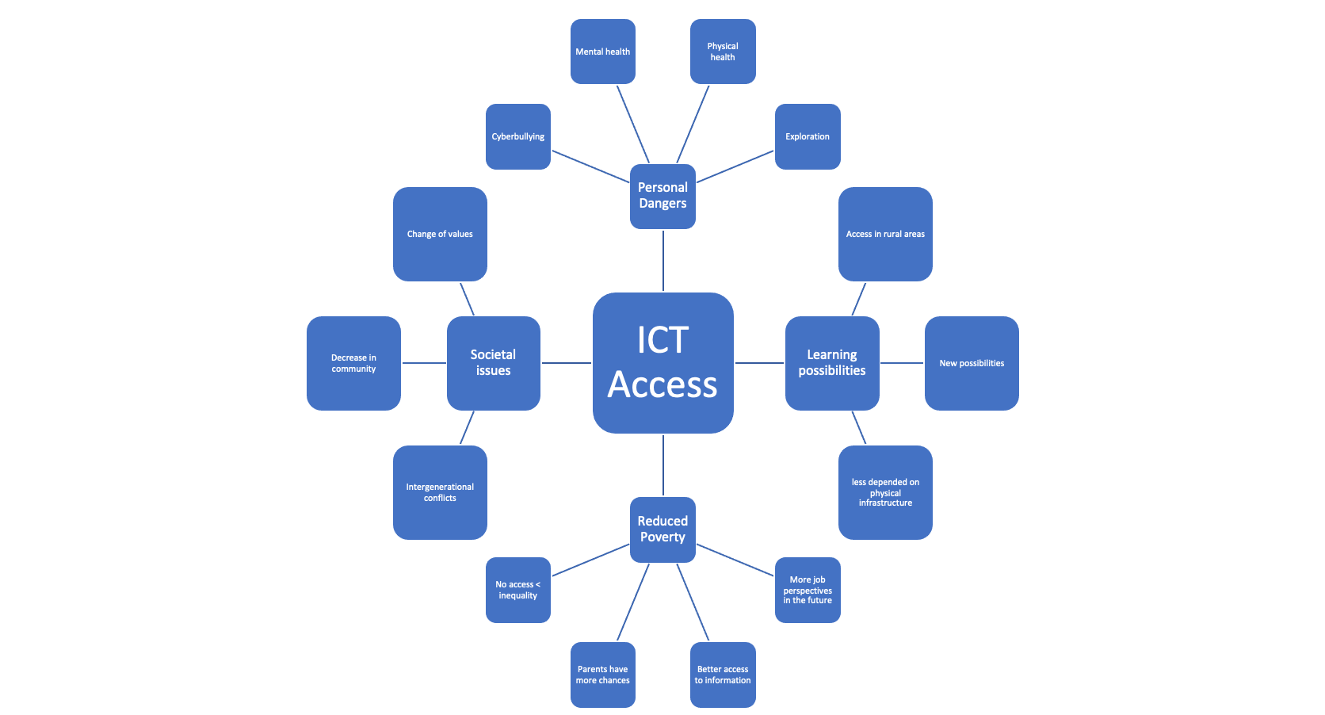
References

Education | UNICEF
Deutscher Gewerschaftbund (DGB). (2022) Atlas der Digitalen Arbeit.
Khan, H., & Williams, J. B. (2012). Poverty Alleviation Through Access to Education: Can E-Learning Deliver? SSRN Electronic Journal. https://doi.org/10.2139/ssrn.1606102
Messerli, P., Murniningtyas, E., Eloundou-Enyegue, P., Foli, E. G., Furman, E., Glassman, A., ... & van Ypersele, J. P. (2019). Global sustainable development report 2019: the future is now–science for achieving sustainable development.

Perspectives – Social Change from the Inside Out. From Fixation to Foundation. From Competition to Change - PMC (nih.gov)
UNICEF. (2020). How many children and young people have internet access at home?: estimating digital connectivity during the COVID-19 pandemic. UNICEF.
World Bank (2020). Individuals using the Internet (% of population).

World Economic Forum (2021) How COVID-19 has changed the way we educate children

Contact Details

Folagbade Akinwunmi Mosaku (University of Ibadan, Nigeria) - folamosaku@gmail.com,

Lu Liu (Sydney Conservatorium of Music, University of Sydney)

Manimala Chanu Asem (University of Bergen, Norway) - Manimala.Asem@uib.no

Rahel Hauk (University of Wageningen, the Netherlands) - rahel.hauk@wur.nl

Stefanie Mallow (University of Costa Rica), - steffimallow@gmail.com

Vijaya (Indian Institute of Technology Guwahati, India) - vijaya19@iitg.ac.in

Zinzi Magoda (Cape Peninsula University of Technology, SA) - nxopoz@cput.ac.za

